COPYMASTER |  | COPY TONE: SCI-FI ESQUE |  |  | VERSION: 1.01
Project Name:  ArteonRW  Model name:  PON-100-RPLHX |  | Product Name:  PREDATOR ORION NEO |  |  | Product Type:  Intel Gaming Desktop
Writer: Clark Gurden |  | Central MKT: Sylvia Pan |  |  | FCS: 3-27-26
1.01
Removed overline from areas that had overline
Modified NV and PC Game pass messaging
//AGW Meta Content
Page Title (60) |  | PREDATOR ORION NEO | Compact Gaming Desktop PC
Meta Description (160) |  | A compact gaming desktop with an Intel® Core™ i9-14900HX processor and an NVIDIA® GeForce RTX™ 5080 GPU — engineered for thermal precision, DDR5 bandwidth, and Wi-Fi 6E connectivity.
//Line/Class Content
Shortened KM (120)  Series Card |  | A compact Predator gaming desktop that pulls high-end power into a tighter orbit of speed, airflow, and control.
//AGW Page Content / Banner
Banner Content - Product Name/Header (40) |  | PREDATOR ORION NEO
Key Message/Page Intro
Key Message/Intro (220) |  | Not every battlestation has room for excess. This compact chassis draws an Intel® Core™ i9-14900HX processor and an NVIDIA® GeForce RTX™ 5080 GPU into one sharp, space-conscious system built to hold speed, heat, and pressure in balance.
Copilot+PC/Windows Message |  | Windows is fast, powerful, and more secure than ever.  Meet the Computer you can talk to.
CTA Button |  | Watch Video
CTA Button Link |  | https://youtu.be/dErqF3-2Z-g
Logos / Badges / Awards
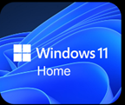 |  | 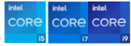 |  | Wi-Fi 6E |  | 
Media Reviews – ENGLISH (ENG)
Publish to USA / CA
Section Headline |  | Media Reviews
Text Content
Image Selection |  | Generic | Generic | Generic |  | Generic
Reviewer Name
Quote (180 Characters)
Button & URL |  | Read More | Read More | Read More
Partner KSP 1
KSP Headline (40) |  | GAME WITHOUT COMPROMISE
KSP Body (250) |  | Intel® Core™ processors (14th Gen) feature newly optimized hybrid architecture and industry-leading technology that enables you to go beyond gaming and creation. With Intel, you can do it all. From progressing in the game to advancing in real life, Intel empowers you to be your best self.
Spec (30) |  | WINDOWS 11 HOME | Up to Intel® CORE™ i9 | Up to 24 CORES |  | Up to 5.8 GHZ
Underline (20) |  | Operating System | processor 14900HX | 8P + 16E |  | Max Turbo Boost
Partner KSP 2
KSP Headline (40) |  | GAME CHANGER
KSP Body (250) |  | GEFORCE RTX 50 SERIES
 |  | POWERED BY NVIDIA BLACKWELL AND AI
Spec (30) |  | UP TO NVIDIA® GEFORCE RTX™ 5080 |  | 5TH GEN TENSOR CORES MAX AI PERFORMANCE
Underline (20) |  | (1,801 AI TOPS) |  | with FP4 & DLSS 4.5
Partner KSP 2.1
Image reference |  | 
Tech Headline |  | NVIDIA DLSS 4.5
Features Headline |  | SUPREME SPEED. SUPERIOR VISUALS. POWERED BY AI.
Features Body |  | DLSS is a revolutionary suite of neural rendering technologies that uses AI to boost FPS, reduce latency, and improve image quality. DLSS 4 introduced Multi Frame Generation (MFG) and transformer models. DLSS 4.5 brings Dynamic MFG and a second-gen transformer model. All backed by an NVIDIA AI supercomputer in the cloud, constantly improving your PC’s gaming capabilities.
Partner KSP 2.2
Image reference |  | 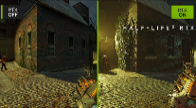
Tech Headline |  | PATH TRACING WITH NEURAL RENDERING
Features Headline |  | GAME-CHANGING REALISM
Features Body |  | The NVIDIA Blackwell architecture unlocks the game-changing realism of path tracing. Experience cinematic quality visuals at unprecedented speed powered by GeForce RTX 50 Series with fourth-gen RT Cores and breakthrough neural rendering technologies accelerated with fifth-gen Tensor Cores.
Partner KSP 2.3
Image reference |  | 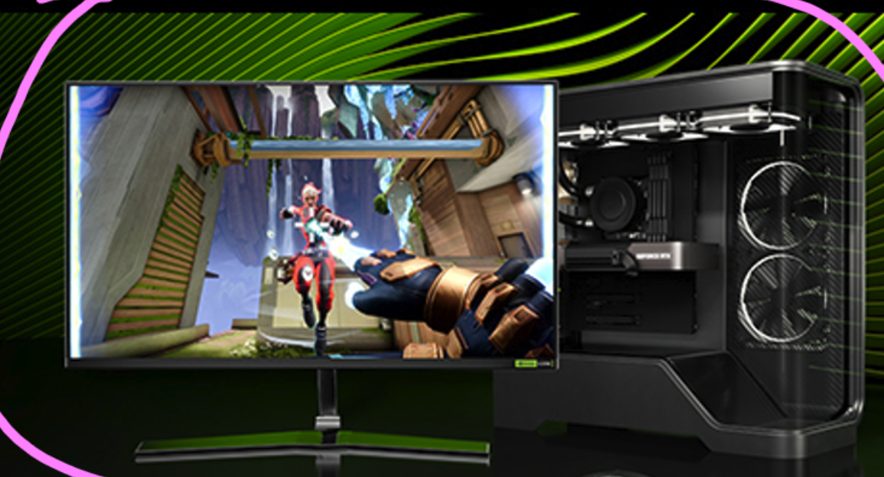
Tech Headline |  | NVIDIA REFLEX 2
Features Headline |  | COMPETE AT WARP SPEED
Features Body |  | Reflex technologies optimize the graphics pipeline for ultimate responsiveness, providing faster target acquisition, quicker reaction times, and improved aim precision in competitive games. Reflex 2 introduces Frame Warp, which further reduces latency based on the game’s latest mouse input.
Partner KSP 2.4
Image reference |  | 
Tech Headline |  | RTX AI PC
Features Headline |  | NVIDIA POWERS THE WORLD’S AI. AND YOURS.
Features Body |  | Upgrade to advanced AI with NVIDIA GeForce RTX™ GPUs and accelerate your gaming, creating, productivity, and development. Thanks to built-in AI processors, you get world-leading AI technology powering your Windows PC.
Acer KSP 1 (Design)
KSP Headline (40) |  | FOUR-FAN AIRFLOW. ZERO PANIC.
KSP Body (250) |  | Some systems try to win the room by taking it over. This one wins it by pulling serious gaming power into a tighter, cleaner form. It stays closer to the desk, closer to the action, and closer to the kind of setup that feels deliberate.
Acer KSP 1.1
KSP Headline (40) |  | EMI-COMPLIANT TEMPERED GLASS
KSP Body (180) |  | A transparent side panel shields against external interference while revealing the internal build with a cleaner, colder edge.
Acer KSP 1.2
KSP Headline (40) |  | ARGB WITH INTENT
KSP Body (180) |  | Internal ARGB lighting adds a sharper visual identity to the chassis, bringing the hardware into view through the transparent side panel and giving your setup a more customized look.
Acer KSP 2
KSP Headline (40) |  | DDR5 XMP MEMORY SPEED
KSP Body (180) |  | DDR5 memory keeps the system responsive when games, background tasks, and fast scene changes hit at once, while XMP support gives compatible modules room to scale beyond standard speeds.
Overline (20) |  | Up to |  | Up to
Spec (30) |  | DDR5 5600 MT/s |  | 7200 MT/s XMP
Acer KSP 3
Image reference |  | 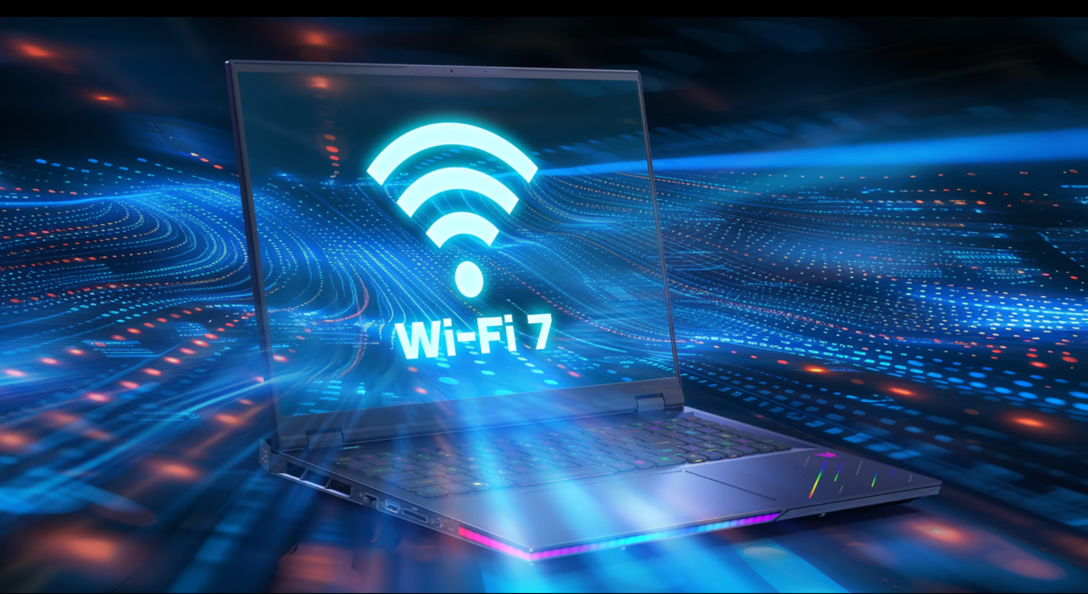  (more product shots where possible)
KSP Headline (40) |  | WI-FI 6E AND USB-C CONNECTIVITY
KSP Body (250) |  | Fast play depends on a clean signal and quick reach. Wi-Fi 6E keeps the wireless path steadier under pressure, while front USB-C and a broad rear I/O array keep displays, peripherals, and fast transfers within easy reach.
Acer KSP 4
KSP Headline (40) |  | ACER INTELLIGENCE SPACE
KSP Body (250) |  | Launch smarter performance through Acer Intelligence Space, your hub for AI-ready tools and hardware insights that fuel productivity, creativity, and gaming
Acer KSP 5
KSP Headline (40) |  | ACERSENSE PRO
KSP Body (250) |  | Access the app to take direct control over your PC, with access to fan speeds, lighting, performance settings, and system monitoring through one clean interface.
Partner KSP
KSP Headline |  | DISCOVER YOUR NEXT FAVORITE GAME
KSP Body |  | Play hundreds of PC games with your new Predator Windows 11 PC and three months of PC Game Pass, including EA Play. With new games added all the time, there’s always something new to play.
Disclaimers
 | This product is not designed for cryptocurrency mining uses. Damages to your product arising from cryptocurrency mining or related activities are excluded from your product’s warranty.
 | The terms HDMI and HDMI High-Definition Multimedia Interface and the HDMI Logo are trademarks or registered trademarks of HDMI Licensing Administrator, Inc. in the United States and other countries.
 | Specifications may vary depending on model and/or region. All models subject to availability
Intel® technologies’ features and benefits depend on system configuration and may require enabled hardware, software, or service activation. Performance varies depending on system configuration. No product or component can be absolutely secure.

© Intel Corporation. Intel, the Intel logo, and other Intel marks are trademarks of Intel Corporation or its subsidiaries. Other names and brands may be claimed as the property of others.
 | ©2026 NVIDIA Corporation. NVIDIA, the NVIDIA logo, GeForce, and GeForce RTX are registered trademarks and/or trademarks of NVIDIA Corporation in the United States and other countries. All other trademarks and copyrights are the property of their respective owners.
 | Max Turbo Frequency is the maximum single-core frequency at which the processor is capable of operating using Intel® Turbo Boost Technology and, if present, Intel® Turbo Boost Max Technology 3.0 and Intel® Thermal Velocity Boost. Frequency is typically measured in gigahertz (GHz), or billion cycles per second.
 | Intel® Turbo Boost Max Technology 3.0 identifies the best performing core(s) on a processor and provides increased performance on those cores through increasing frequency as needed by taking advantage of power and thermal headroom. Intel® Turbo Boost Max Technology 3.0 frequency is the clock frequency of the CPU when running in this mode.
 | Maximum P-core turbo frequency derived from Intel® Turbo Boost Technology.
 | Specifications may vary depending on model and/or region. All models subject to availability.
 | P refers to Performance-cores, E refers to Efficient-cores, and LPE refers to Low Power Efficient-cores
 | AI features may require software purchase, subscription or enablement by a software or platform provider, or may have specific configuration or compatibility requirements. Details at www.intel.com/aipc.
 | Depending on the region, this PC may be bundled with a mouse. In such case, the mouse may not support NVIDIA Reflex functionality. Acer does not claim or guarantee compatibility of the bundled mouse with this feature.
 | Memory limits depend on the OS. For details on Windows 11 Home and other versions, visit Microsoft Learn: https://learn.microsoft.com/en-us/windows/win32/memory/memory-limits-for-windows-releases.
 | Claim within 30 days of device activation. New and eligible returning members only. Valid payment method required. Subscription continues automatically at regular monthly price unless cancelled. Subject to xbox.com/subscriptionterms. Benefits vary by Xbox Game Pass plan. Terms and Exclusions apply. Game library varies over time, by region, device, and Xbox Game Pass plan. xbox.com/gamepass. For details on partner subscriptions included with PC Game Pass: https://www.ea.com/ea-play/, https://store.ubisoft.com/ubisoftplus/classics. In-game benefits vary by game, region, and over time. Game must be installed to access in-game benefits.

